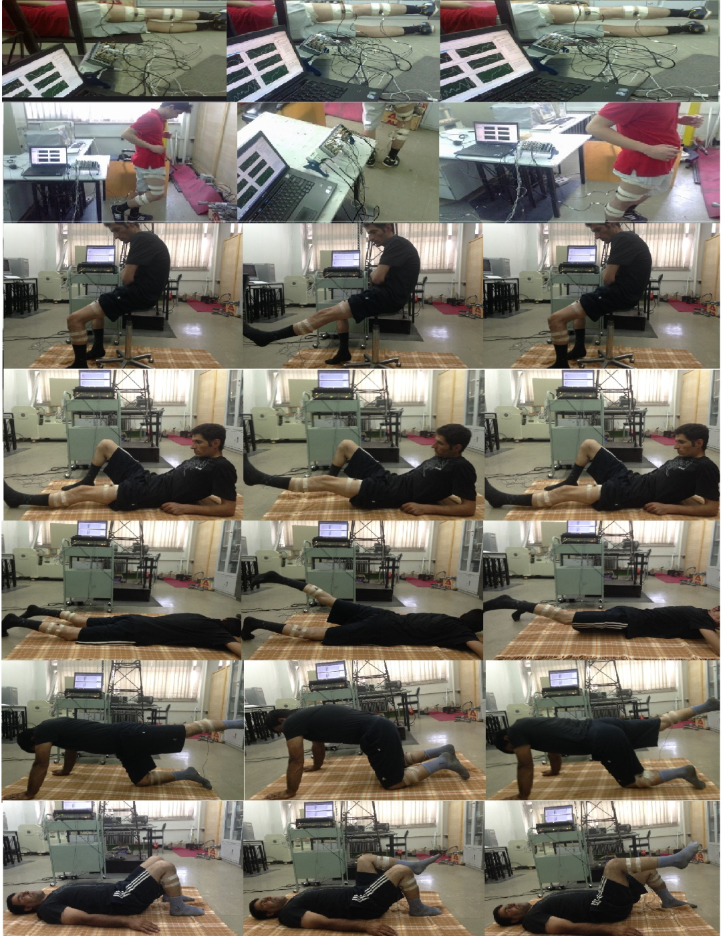
Supplementary 1. Seven models of the experimental tests on the patients

